You are given an m x n grid grid of values 0, 1, or 2, where:

* each 0 marks **an empty land** that you can pass by freely,
* each 1 marks **a building** that you cannot pass through, and
* each 2 marks **an obstacle** that you cannot pass through.

You want to build a house on an empty land that reaches all buildings in the **shortest total travel** distance. You can only move up, down, left, and right.

Return *the* ***shortest travel distance*** *for such a house*. If it is not possible to build such a house according to the above rules, return -1.

The **total travel distance** is the sum of the distances between the houses of the friends and the meeting point.

The distance is calculated using [Manhattan Distance](http://en.wikipedia.org/wiki/Taxicab_geometry), where distance(p1, p2) = |p2.x - p1.x| + |p2.y - p1.y|.

**Example 1:**

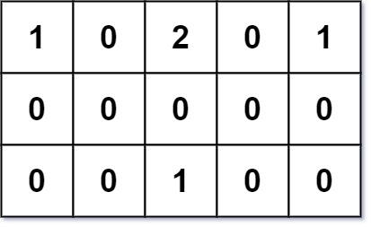

Input: grid = [[1,0,2,0,1],[0,0,0,0,0],[0,0,1,0,0]]  
Output: 7  
Explanation: Given three buildings at (0,0), (0,4), (2,2), and an obstacle at (0,2).  
The point (1,2) is an ideal empty land to build a house, as the total travel distance of 3+3+1=7 is minimal.  
So return 7.

**Example 2:**

Input: grid = [[1,0]]  
Output: 1

**Example 3:**

Input: grid = [[1]]  
Output: -1

**Constraints:**

* m == grid.length
* n == grid[i].length
* 1 <= m, n <= 50
* grid[i][j] is either 0, 1, or 2.
* There will be **at least one** building in the grid.